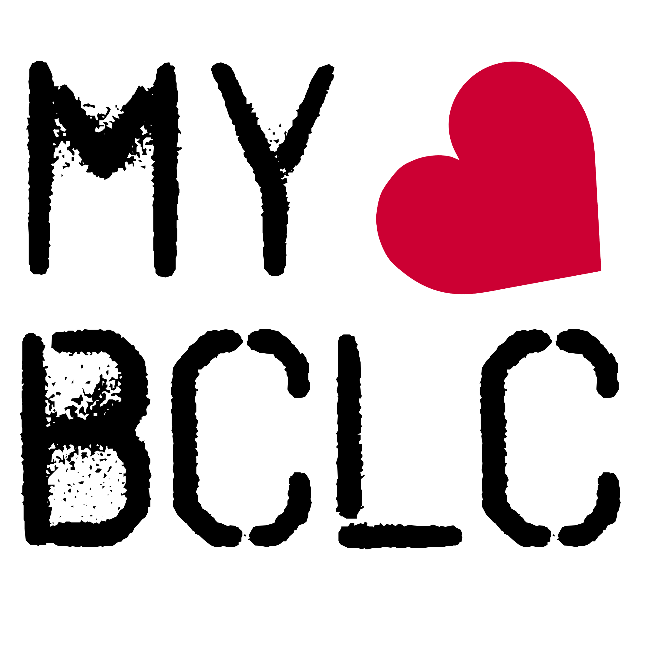
BCLC Church Calendar: Winter 2023-2024
All services are from 10:30am -12 noon unless stated otherwise

BCLC welcomes visitors – we are a friendly bunch so please feel free to join us for all or part of any of the meetings below.

Our current theme is ‘GOD IS LOVE’ – the essence of God’s character is love; love is not just what God does, it is who he IS. So, where you see ‘speaker’ in the list below, this will be the theme throughout 2024.

Crib Chat – these are less formal meetings in our coffee shop called, The Crib. It may involve prayer, discussion, testimonies or just be a social time.

Communion – we take communion regularly at BCLC; it’s our way of celebrating the fantastic love that God has for all people everywhere. You’re very welcome to join us!

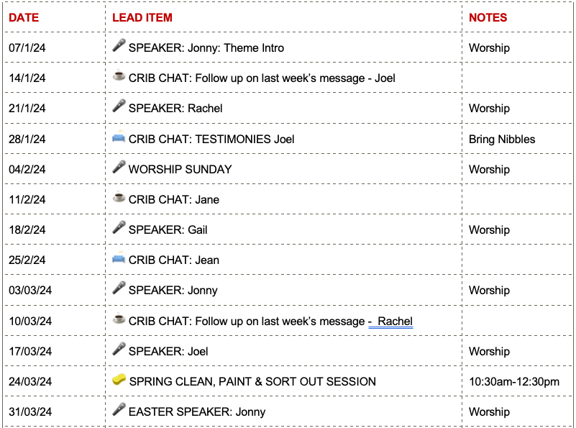

We look forward to welcoming you!
Learn more at: www.myBCLC.org/whats-on

